Human Computer Interaction – Group 7

Sean Palmer, Loiy Alsmadi, Daniel Redmond, Carl MacDiarmada, Daniel Kavanagh

Introduction

For our assignment, we decided to remake DITs library section of the website. We decided to do this for our assignment because every single one of us used the website and found it to be poorly laid out and made. We found that site was too cluttered, and wanted to simplify it and make the interface easier to use. Our aim for the assignment was to create a simple and easy to use website. The purpose of the chosen assignment was to create a website that students would use with ease, and like using it. We decided to focus on five aspects of the site and re-do them. These five different aspects are: the homepage, searching the library catalogue, the opening hours of the various DIT libraries, an exam papers page and a printing page.

The homepage:

The original page for homepage of DITs library site is very unappealing to look at. It is very cluttered, and there is information overload. There is so many links, that trying to find the one that you want it quite difficult. We wanted to simplify the homepage and make the whole interface easier to use. We wanted include some of Gestalts laws, such as similarity.

Search:

Searching through the library catalogue, is a very useful and powerful tool for students. However, the search feature is implemented on the homepage in a rather unusual place. It is in the centre of the page. This interrupts the flow of the homepage. We decided to give the search feature its own page.

Opening Hours:

The current opening hours is an extremely long webpage. It contains all of the opening times for all the different DIT libraries. We wanted to decrease the size of this page and make it more simple and easy to use. As the current page shows all of the times it is easy to read the wrong opening hours, to combat this we decided to only show one library at a time. To do this we let the user choose which library opening hours they would like to see.

Exam Papers:

Accessing the exam papers through DITs library website is a very tedious and long task. As many students do this a lot especially around the exams time. We wanted to simplify this task and make it is easier to get the exam papers you want. Instead of having to go through several pages to get to the exam papers page. We wanted to just have one page that students can go to. On this page all the user has to do is enter in the exam papers they want and they will be able to download the exam papers. This is a very simple process compared to going through several pages to do the same thing.

Printing:

As most students print from the library and use the printers there, we wanted students to be able to print straight from the library website. Currently if a student wants to print in DIT, they have to go to an altogether different site. We didn’t want to have students having to do an extra thing that can be avoided. We wanted to simplify the process, so we took the printing process from the external site and implemented it into our site.

Integration

We based the layout of our web application on the original design of DITs website. We used the same header as the one that is seen throughout DITs webpages. This is to give consistency with the other DIT pages. As seen in some of DITs pages there is a sidebar for various links and information to the right of the main content. We used this idea and created a navigation box for our various pages. The background for this navigation box is the same colour as the navigation bar in the header that DIT uses. Using the same colour, expresses Similarity, this is one of Gestalts laws. Throughout our application we use this colour several times, each time enforcing an appealing colour scheme. Every page we created followed the same guideline. The header, footer and the navigational box on the left were the same. The main content changed depending on the page.

For interactivity, we used drop down bars, search boxes, a navigation box that maps to the other pages throughout the site. We wanted to make interacting and using the site easy so we only used simple components.

The data that is handled in our application is varied. For printing, you could upload a file to print. When searching through the catalogue a database is needed.

This is the template we followed throughout our site. We used a universal header that is represented by the DIT LINKS. We included a side bar for navigation on the right. The main content is placed in the centre. On the right we have a bar that was used for various features depending on the page. This template was made for our homepage, but we applied to all our pages.

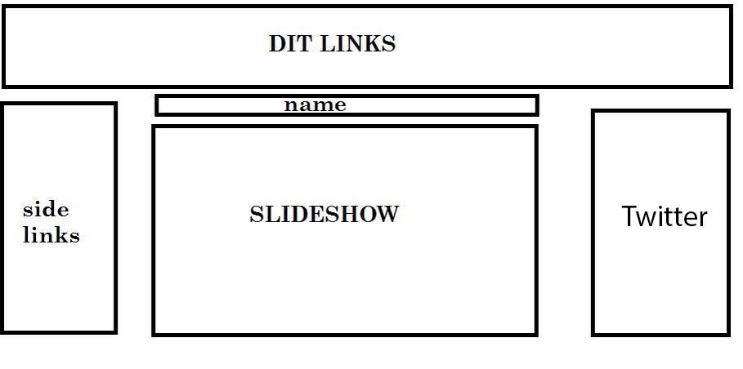

Presentation

This following section displays our finished prototype of our web application for DITs library site.

This is the homepage that we created. It shows the header, footer and sidebar that is present in all our pages. On the right shows the embedded twitter feed for DITs library account. The image in the middle is part of a slideshow that displays for the website.

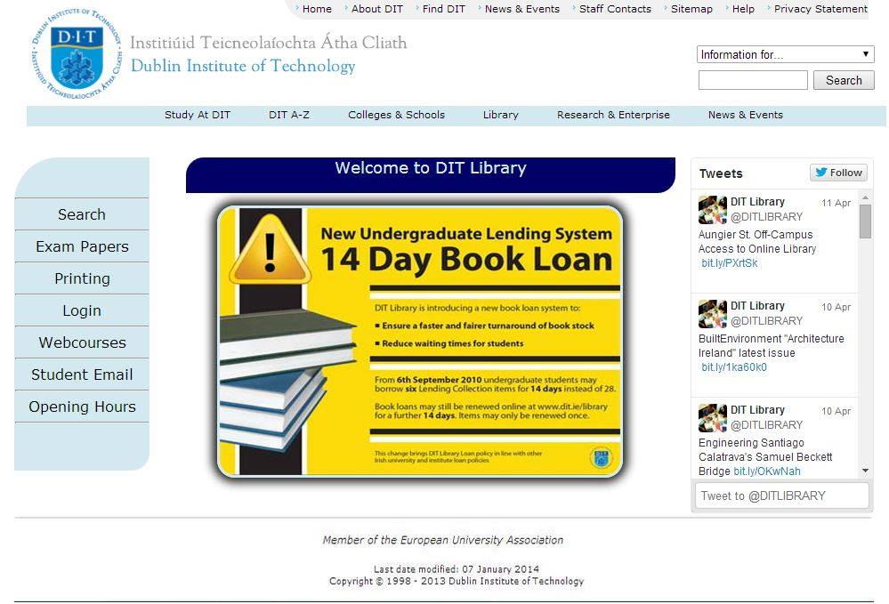

This is another image of our homepage, this is displaying the functionality of the slideshow as the main image has changed.

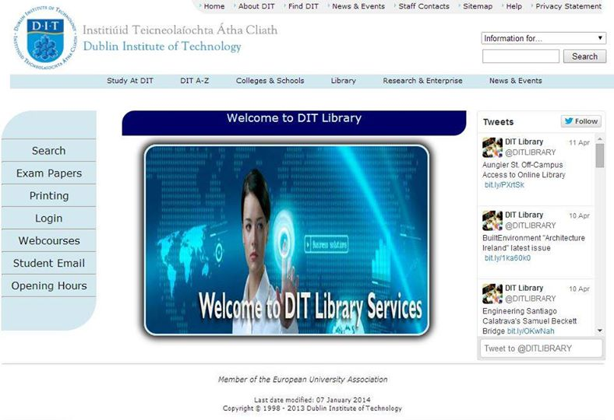

This is the exam papers page for our website. It shows one of the ways a user can interact with the site using the dropdown bars.

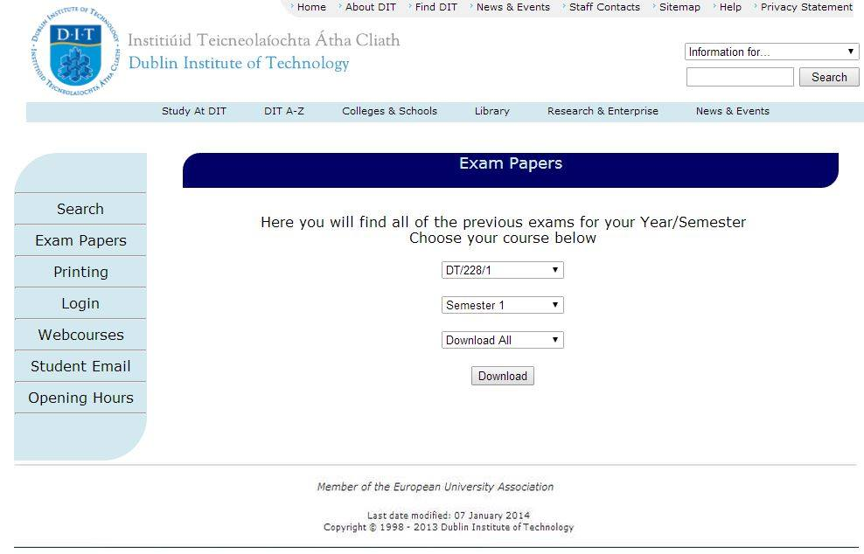

This is the opening hour’s page of our site. As you can see we have incorporated Gestalts Laws of Similarity with the timetable. As the table is of similar colours, the user perceives it as one. We wanted the page to only show one schedule as with the old layout it showed all of the schedules and it was just too much for the user.

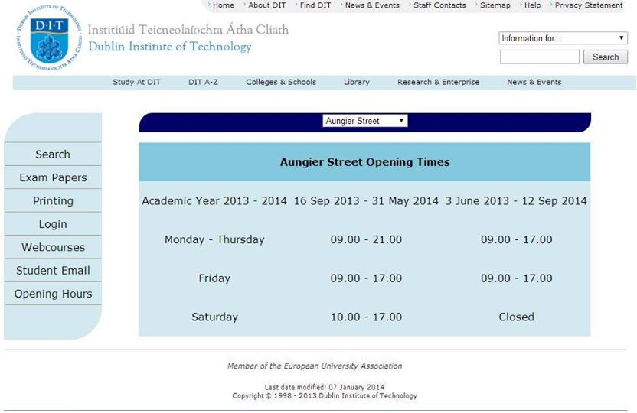

Here is another view of the opening hour’s page. Here you can see the simple and easy to use interactivity of the site, as the user has changed the library schedule they would like to see.

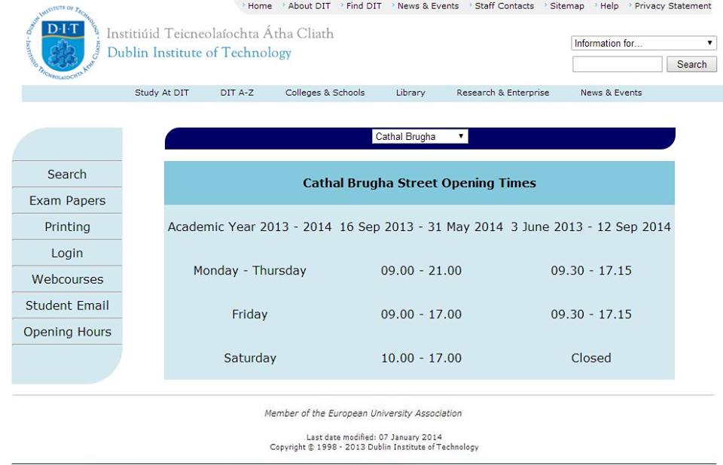

Here is the printing page of our site. This page is based off the external printing site DIT uses. You can clearly see the simple and minimal design. The buttons are large and easily visible making this page easily accessible for the visually impaired.

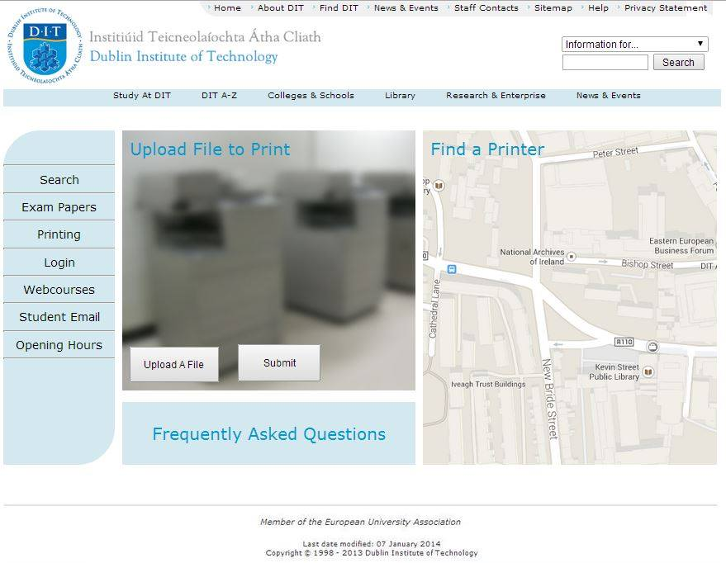

This is Searching page. Here you can search through the library catalogue. Here we searched for C#, and are showing the results.

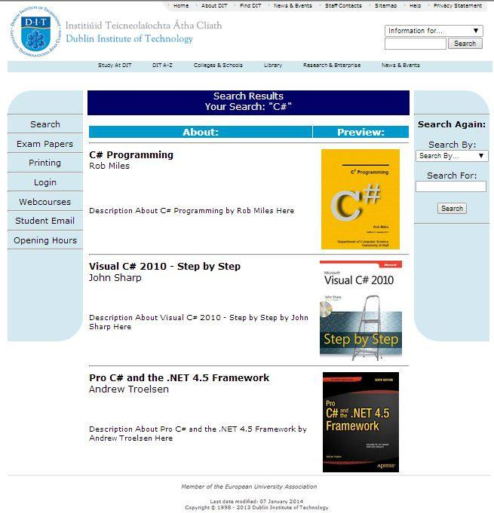

Conclusion:

Our objective was to redesign the Library section of DIT’s website, to make it more to user friendly, reduce the clutter, and make it similar in design to the other sections of DIT’s website. We focused on five aspects of the website; the homepage, the library catalogue search page, the opening hours page, the exam papers page, and the DIT printing page.

During the redesign of the website, the group faced many challenges. The first and most difficult was to strike a balance between making the design unique and modern and having the style consistent with the rest of DIT’s website. We decided to keep the header of DIT’s website, as it is similar across all of their sites. We also decided that keeping the same colour scheme would be appropriate. This is to maintain a certain level of consistency across the site.

We learned an important lesson during the completion of this assignment, time management, and delegation is important while working in a group. We failed to properly split up to project to the members of the group we began nearing the submission date.

Another problem we faced was keeping a consistent design. As our ideas developed the sections we had assigned became different. This was caused by a certain lack of communication between the group members. This lead to our project taking longer than it should’ve as we had to change some of the pages, to keep the design consistent.

For the future development of our system, we would implement the back end of our system. This would include designing a database to store exam papers, the library book catalogue and user account information. We would also add some more functionality to our website, such as the ability to reserve a book, or add credit to a printing account.